Cumann Lúthchleas Gael

County Games Development Manager.

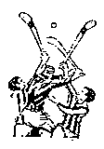  County Games  Development Manager  Dudley Farrell  Mobile 087-9033789  Mobile 087-2844166  E-Mail  dudley.farrell.gamesmanager. meath@gaa.ie  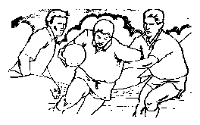  County Games  Development Manager | Nobber,  Co. Meath.  TO WHOM IT MAY CONCERN,  The “Keith Fagan golf classic” is being held in the County Meath Golf club in Trim on the Friday, 28th May 2010. All proceeds are going directly to Christine and kids.  Four persons per team (best two scores each hole) and we will have Gui and non- Gui prices. Entry per team is €300.00. Or anyone wishing to give Sponsorship will cost €50.00.  If anyone would like to enter a team they can contact Dudley Farrell on 087-2844166.  I can arrange a time on the timesheet. The entry fee includes a meal in the golf club as each team finishes.  Kind Regards.  Dudley Farrell  County Games Development Manager

