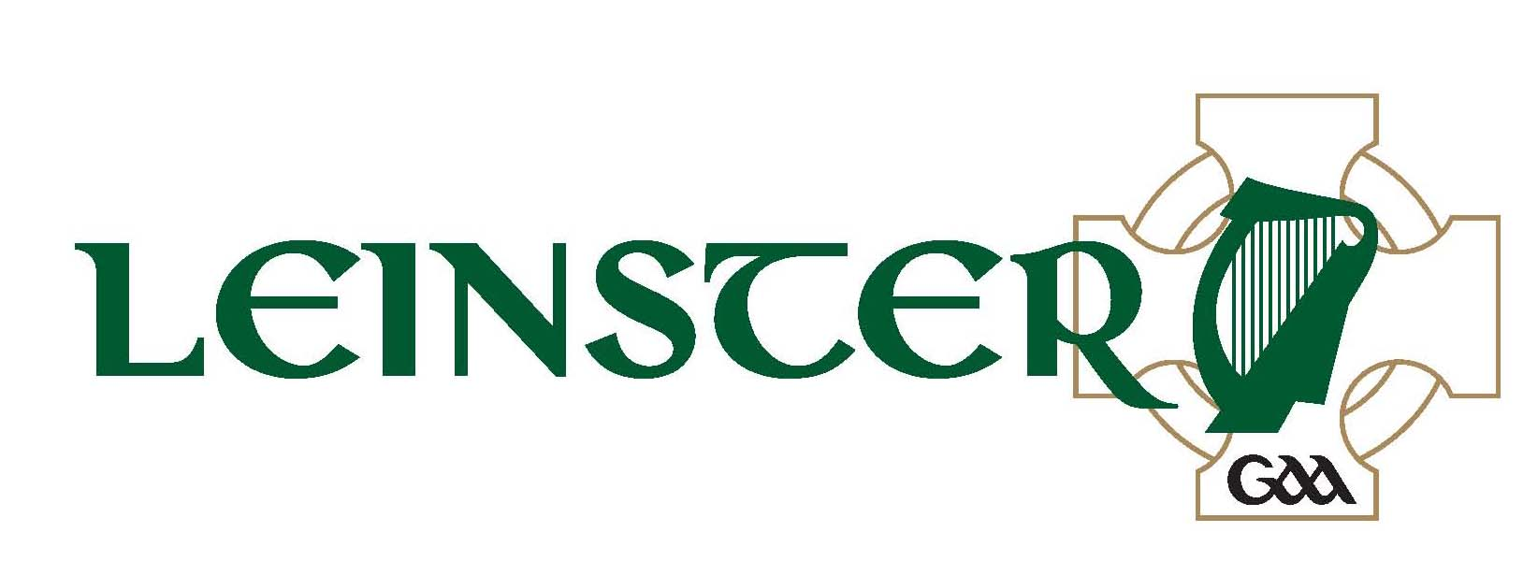
Aras Laighean,
Portlaoise,
Co. Laois
(057) 8682000 (phone)
(057) 8620398 (fax)

Comhairle Laighean C.L.G.
Adult Club Group Application Form

ALL GROUP PASSES ARE FOR TERRACE

Event:- Leinster G.A.A. S.F.C. – Wicklow v Meath @ 7.00pm

Date:- 15th June 2013 Venue:- Aughrim

Club:- __________________________________________________

Club Secretary’s Name:- __________________________________

Address:- __________________________________________________

_____________________________________________________________

Club Secretary’s Phone No’s:- Home: ______________ Work: _____________
Mobile: ___________

Club Secretary’s Signature: - __________________________________

No. of Tickets Required: -________________________________
(Minimum 15 - Maximum 50)

PRICE:- €5 EACH TERRACE

Cheque/Postal order must accompany application.

Application Form to be returned to Aras Laighean on/before Tuesday, 11th June 2013 with a cheque or postal order.
Application Forms must be submitted via Club Secretary.

