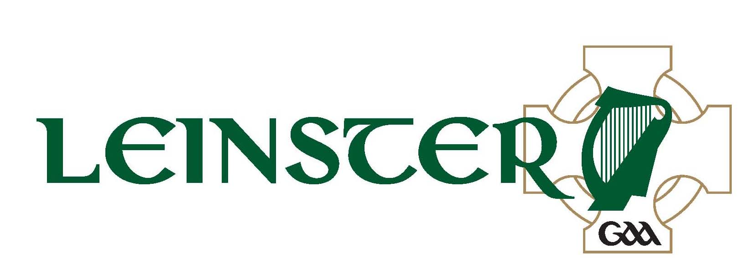
Aras Laighean,
Portlaoise,
Co. Laois
(057) 8682000 (phone)
(057) 8620398 (fax)

Comhairle Laighean C.L.G.
Adult Club Group Application Form

ADULT GROUP TICKETS – DAVIN STAND & DESIGNATED SECTIONS OF HOGAN STAND

Event:- Leinster G.A.A. S.F.C. Final –Dublin v Meath (2pm) & Electric Ireland Leinster M.F.C. Final (12.00noon)

Date:- 14th July 2013 Venue:- Croke Park

Club:- __________________________________________________

Club Secretary’s Name:- __________________________________

Address:- __________________________________________________

_____________________________________________________________

Club Secretary’s Phone No’s:- Home: _________ Work: ________Mobile: ___________

Club Secretary’s Signature: - __________________________________

No. of Tickets Required: -________________________________
(Minimum 15 - Maximum 50)

PRICE:- €20 EACH Cheque/Postal order must accompany application.

Application Form to be returned to Aras Laighean on/before Tuesday, 9th July 2013 with a cheque or postal order.

Application Forms must be submitted via Club
Secretary.

