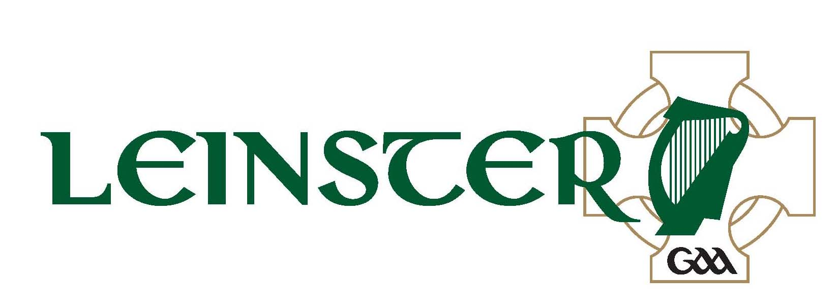
Aras Laighean,
Portlaoise,
Co. Laois
(057) 8682000 (phone)
(057) 8620398 (fax)

Comhairle Laighean C.L.G.
Club Group Pass U-16 Application Form

ALL GROUP PASSES ARE FOR TERRACE ONLY

Event:- Leinster G.A.A. S.F.C. – Carlow vMeath @ 3.30pm

Date:- 15th June 2014 Venue:- Dr Cullen Park, Carlow.

Club:- __________________________________________________

Club Secretary’s Name:- __________________________________

Address:- __________________________________________________

_____________________________________________________________

Club Secretary’s Phone No’s:- Home: _________ Work: ________Mobile: ___________

No. of Juvenile Tickets Required: -________________________________
List Teams Involved:- ___________________________________________

_____________________________________________________________

No. of Adults Travelling with Group:- ___________________________

Note: €2 per Child. 1 Adult per 10 Juveniles free of Charge. Adults outside of quota €10 per ticket. Cheque/Postal order must accompany application.

Name and Phone No. of person in charge of the trip on the day:-

_____________________________________________________________

Application Form to be returned to Aras Laighean on/before Tuesday, 10th June 2014 with a cheque or postal order.

