To: Each County Secretary and County Children’s Officer
Re: The Commencement of the National Vetting Bureau
(Children and Vulnerable Persons) Acts 2012 to 2016
Date: 30 March 2016

I write to you in advance of new legal requirements that will come into effect in relation to
the vetting of those who work with children in the GAA. I would be grateful if you would
forward this correspondence to each Club in your County and request of the Clubs to inform
our membership of its contents.

We are informed that the National Vetting Bureau (Children and Vulnerable Persons) Acts
shall in all probability commence on 29 April 2016 thus introducing the legal requirement
that all GAA personnel who work with children and vulnerable adults shall be required to
be vetted.

This measure will bring us in line with current practices in the Six Counties and with other
European Countries.

When the Acts are commenced by the Minister for Justice the National Vetting Bureau, formerly known as the Garda Central Vetting Bureau, will come into being. The immediate issues that require our attention are:

- The commencement of the National Vetting Bureau Act on 29 April 2016
- As and from that date the GAA will only engage in e-vetting or on line vetting procedures thus eliminating the current paper vetting that has been in existence since 2009.
- We will commence with ‘Retrospective Vetting’ i.e. the vetting of persons who currently work with children in the GAA but have not been vetted to date
- We will continue to vet all new applicants who wish to work with children in the GAA prior to them undertaking any such role
- We will gradually engage in the re-vetting of those previously vetted under our old vetting procedures

1 Commencement of the National Vetting Bureau (Children and Vulnerable Persons) Acts
While the ‘National Vetting Bureau Act’ has previously passed all stages of the House of the Oireachtas it was never fully commenced by the relevant Minister. We are however informed by both the Department of Justice and the Garda Central Vetting Bureau that the likely date for the commencement of the Act is 29 April 2016.

What this effectively means is that the GAA practice of vetting personnel who work with children as part of our voluntary good practice procedures will became a mandatory requirement in law on the island of Ireland both North and South as and from 29 April 2016 given that it is already a legal requirement in the six counties.
In our case it is worth noting that should any person who has not been vetted, and who has not previously worked with children in the GAA, and who subsequently seeks on our behalf to work with children and or vulnerable adults after the Act commences they will be in breach of the law. Should we employ or recruit a person to do this work who has not been vetted we also will breaching the law.

While certain leeway has been agreed so as to enable us retrospectively vet those who, for whatever reason, are currently working with children in the GAA and have not been vetted to date, no such leeway exists for new entrants i.e. people who seek to work for the first time with children in the GAA after that date.

What does the Act state in relation to vetting personnel e.g. coaches of underage teams
In accordance with the Act it is an offence if we fail to vet a GAA nominated person who subsequently works with children on our behalf. Section 12 of the Act prohibits the engagement of persons to do relevant work or activities relating to children or other vulnerable persons, unless that person has been subject to the vetting procedures under the Act.

Any person currently vetted by the GAA is covered under the Act as their vetting acceptance in essence transfers over under the new Act. For the purpose of clarification the National Vetting Bureau Act in GAA terms applies to any person who carries out a role of responsibility with an underage player i.e. a person who is under 18 yrs. of age. This also applies to any coach, manager, selector of a senior squad if that squad includes a person under 18 yrs. of age. The Act also covers those who work with vulnerable adults.

2 E-Vetting replacing paper vetting applications
On the commencement of the Act the National Vetting Bureau will introduce E-Vetting or a system of applying on line for vetting. The E-Vetting system will be limited to four organisations in the first instance, one of whom is the GAA. The GAA is pleased to have been one of the four chosen organisations along with the Teachers Council, Volunteering Ireland and the DAA. The piloting of E-Vetting by the National Vetting Bureau indicates that we can get turnaround times for the processing of vetting forms down to a few days rather than many weeks as experienced in the past. All interaction with the vetting applicant will, following completion of an initial identity verification form, be done via email.

What this means is that the GAA must make itself ready and be in a position to deliver on E-Vetting following the commencement of the Act on 29 April 2016. This will be a challenge but as we have proven in relation to player registration in the past working on-line is not an insurmountable task for our Association.

As we move towards E-Vetting we will utilise the services of both our Club and County Children’s Officers to enable this happen. For example identification verification of a person applying for vetting will be required at local level before the applicant can access the vetting form and submit it on to Croke Park for processing with the National Vetting Bureau.

Ending paper vetting in the GAA
As ‘paper vetting applications ‘ come to an end the GAA will be required to wind down that process in preparation for the introduction of E Vetting as quickly as possible after 29 April 2016. Once the Association commences E Vetting we will not be permitted to revert to ‘paper applications’ by the National Vetting Bureau.

To enable us prepare for commencement of this new service the following dates in relation to vetting shall apply in the GAA:

- 7 April 2016: The GAA shall cease accepting any paper vetting applications from
members and units of the Association as and from close of business on 7 April 2016. Any vetting application received after that date shall not be processed for forwarding to the Garda Central Vetting Bureau due to their own cut off dates.

- 15 April 2016: The Garda Central Vetting Bureau shall cease accepting vetting forms from GAA in advance of the commencement of E Vetting on 15 April 2016. Any forms that have been accepted by the Garda Central Vetting Bureau up to and including that date shall be processed.

- 1 May 2016: The GAA shall commence E-Vetting and shall as a matter of priority concentrate on retrospective vetting and on the e-vetting of new applicants.

3 What is Retrospective Vetting?
A Ministerial directive has been issued in relation to how we implement what is termed ‘Retrospective Vetting’. In the GAA this term shall be used to refer to any person who is currently working in a role of responsibility with children e.g. a coach, trainer, manager etc. and who has not been previously vetted in accordance with the requirements of the Act. Any such person will be an immediate priority for the GAA as we deem them to be currently in breach of Rule 1:13 of our Official Guide and they will also, after a short period of time, be in breach of the Act. Any such person must be vetted immediately under our new vetting procedures.

4 E-Vetting new applicants
As previously referred to four organisations have been chosen to commence the E-Vetting (on line vetting) of its members. The GAA as one of the four includes Handball and Rounders personnel in our vetting services but it does not, at this stage, include Ladies Gaelic Football or Camogie membership.

While Retrospective Vetting may be a priority for the Association so also is the E-Vetting of new applicants i.e. a person who we have requested or appointed to work with children or vulnerable adults and who has not worked in such a capacity to date and who has not been vetted to date by the GAA. Such a person would be deemed a new vetting applicant.

5 Re-vetting of current GAA personnel who have been previously vetted
To date the GAA has vetted almost 75,000 people through the Garda Central Vetting Bureau. Some of those vetted have by now been vetted for the second time and many of the 75,000 includes host family members for Féile na nGael and Féile Peile.

We will not commence the E-Vetting of persons previously vetted until later this year as it is not an immediate requirement of the Act. When the new E-Vetting structures have been fully tested and when necessary training at County level has taken place we will then announce the re-vetting of personnel in the GAA which will take place on a County by County basis. Each County will receive sufficient notice and an agreed timescale in which to complete the e-vetting of those who work with children in the GAA.

To facilitate each Club in identifying who has been issued with a GAA vetting acceptance letter to date we shall issue, via the County Secretary, a list of all personnel vetted on a Club by Club basis (as registered by them in their vetting application form) in early May. This will assist Clubs in each County to identify who amongst their membership may still require to be vetted due to their roles with underage teams or personnel.

Briefing on E-Vetting for County Childrens Officers
As part of our series of Child Welfare Information Seminars, organised by the National Child Welfare and Protection Committee, the next Information Seminar on 23 April in Croke Park, 10.30 am to 1.30 pm, will receive a detailed presentation on the new E-Vetting system and how it will operate in the GAA. Each County Children’s Officer has been invited to this Information Seminar and should they be unable to attend please ensure that a substitute delegate attends in their place. County Children’s Officers from LGFA and Camogie have also been invited to attend.

I would request that this correspondence is shared with your Clubs and any further update on this matter will be contained in the April GAA Club Newsletter from Croke Park.

Le dea mhéin,

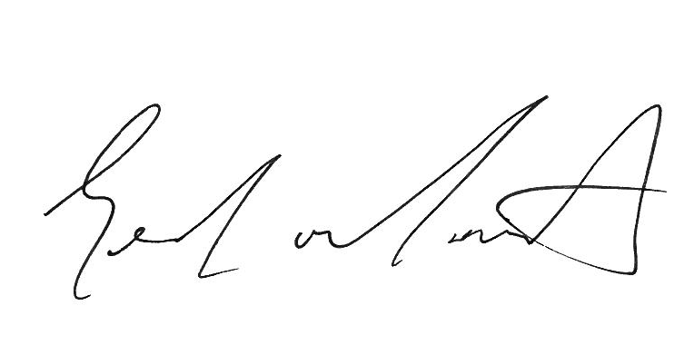
Gearóid Ó Maoilmhichíl
Child Welfare Manager

